|  |  |
| --- | --- |
| No. of Pages | 3 |
| No. of Questions | 7 |

**Student Name: ________________________________ ID:____________________**

**Department of Computer Science and Engineering**

**Midterm Examination Summer 2017**

**CSE 420: Compiler Design**

**Total Marks: 40 Time Allowed: 1 Hour**

|  |
| --- |
| * You HAVE TO RETURN this question paper and the answer script at the end of the exam. Your script will not be checked unless you do so. * You are not allowed to communicate with any other candidate in any way whatsoever. |

**Section A (There are 2 questions, answer any 1 out of them) [4*1=4]**

1. Draw the basic block diagram of Compilation process. [4]

2. What do you understand by left recursion and left factoring, please explain with valid example. [4]

**Section B (There are 3 questions, answer any 2 out of them) [10*2=20]**

1. a) Convert following NFA to DFA using **subset construction methodology**. [6]

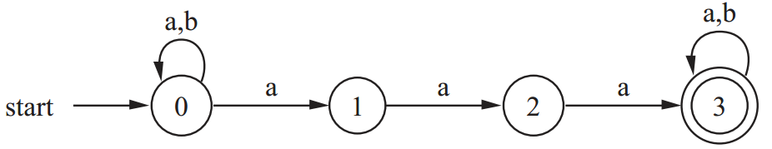

b) Convert the following DFA to Regular expression (RE). [4]

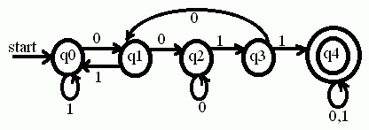

1. Convert RE (Regular Expression) “01*1(0|11)*(0|1)”to corresponding DFA (using first-pos, last-pos and follow-pos). [10]
2. a) Construct a table-based LL(1) predictive parser of following grammar:

*E -> TX*

*T -> (E) | int Y*

*X -> +E | e*

*Y -> *T |e*

Where, terminal symbols are {int, *, +, (, )}. [6]

b) Parse the input string “(a,a)” using following resources: [4]



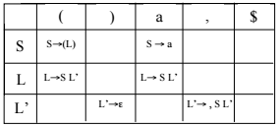

**Section C**

1. Consider the following grammar.

*A -> bF*

*F -> Ax | B*

*B -> xG*

*G -> xB |e*

1. Compute the LR(0) automation for the grammar. [6]
2. Construct the LR(0) parsing table. [6]

2. **Parse** input string “***acbbac*”** using following resources: [5]

